**Name of Student: Ramit Bose**

**Reg.No.: 21BCE1316**

**Ex. No:7**

**Date :01-04-2023**

**Interaction Models**

Aim:

Preparing the Interaction model/Sequence Diagram for my application i.e., ATM Management System in StarUML.

Description:

Sequence Diagram (Interaction Model): typically show the flow of functionality through a use case, and consist of the following components:   
1. Actors, involved in the functionality   
2. Objects, that a system needs to provide the functionality   
3. Messages, which represent communication between objects

Output Screenshot:

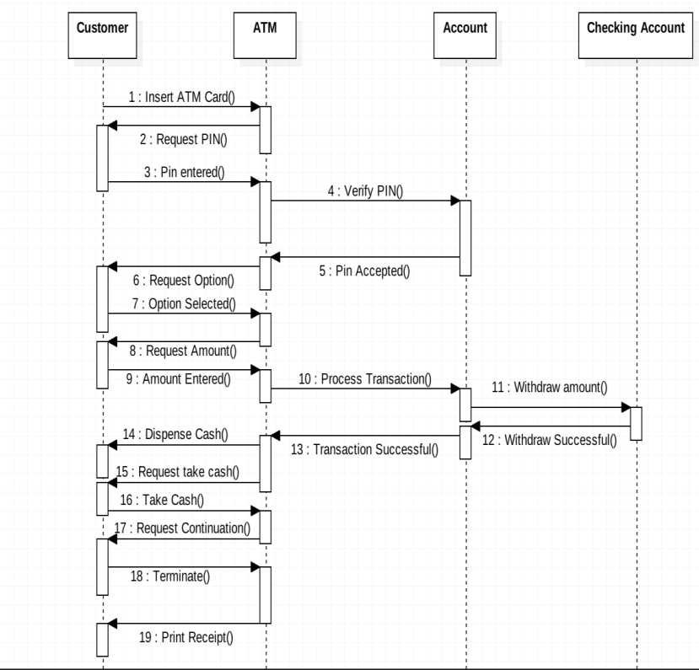

Result:

Hence, we have made the Interaction Model for our project ATM Management System